|  |  |  |  |  |
| --- | --- | --- | --- | --- |
| **Identifier** | **Page title** | **errors/ what we have to do** | **Mahi/Miraj Comments** | **Jay Gray comment** |
| kg-item-10 | Goals for representing knowledge | Here will be one/single SVG for left text and right text | Text will be one-line, blue box will fit with text, Text line out of range/ canvas/ page |  |
| kg-item-11 | Ontology | Here we’ll add text by HTML tag |  |  |
| kg-item-12 | The Gene Ontology (1) | SVG may not work, so we use Transparent background PNG, three in one PNG |  |  |
| kg-item-13 | The Gene Ontology (2) | **I Re-use GO-biological-process.svg** | Have lot of problems, text box, font, font size and more errors |  |
| kg-item-14 | The GO branches | You send me all three source PNG for position in an SVG, I need reuse | Text lien out of range/ canvas/ page, text box error, text will be one line |  |
| kg-item-15 | Knowledge Graphs | Text left is HTML, triangle + triangle-text and text right is SVG | Text line out of range/ canvas/ page |  |
| kg-item-16 | Example knowledge graphs | HTML text only |  |  |
| kg-item-17 | Google Knowledge Graph | will be HTML text left and the right SVG. Will not use any red arrows for this slide | Text line out of range/ canvas/ page |  |
| kg-item-18 | Why Knowledge Graphs? | You provide me 3 PNG to be positioned and labeled in an SVG, I’ll reuse, need add a question mark | Text line out of range/ canvas/ page |  |
| kg-item-19 | Implicit relations for hypothesis generation ABC model | single SVG for text and ABC diagram | Text will be one-line, Text line out of range/ canvas/ page |  |
| kg-item-20 | Open Discovery and Closed Discovery | Subset of kg-item-19 | Text line out of range/ canvas/ page, blue box not fit with text |  |
| kg-item-21 | Example question: drug repurposing | Will be single SVG for all and text | Text line out of range/ canvas/ page, and others errors |  |
| kg-item-22 | Implicit relations for hypothesis generation | Reuse subset from kg-item-20 and take 3 images from kg-item-18 | Wrong image adds and more errors |  |
| kg-item-23 | Querying a knowledge graph with SPARQL | 1 SVG and left text in HTML | Text line out of range/ canvas/ page, Color box not fit with text |  |
| kg-item-24 | Metformin’s unique id: Q19484 Treats property id: P2175 (1) | Top 1 PNG and bottom PNG, so will be 2 PNG is a single SVG | Text out of page/ canvas, Wrong work, not Follow you command |  |
| kg-item-25 | Metformin’s unique id: Q19484 Treats property id: P2175 (2) | Same as kg-item-24 but this two different PNGs | Text out of page/ canvas, Wrong work, not Follow you command |  |
| kg-item-26 | Example question: drug repurposing | Here will be two SVG. The bottom SVG is a variation of kg-item-23, kg-item 24 and kg-item-25. The top SVG is a variation of kg-item-21 | Text out of page/ canvas, Wrong work, not Follow you command |  |
| kg-item-27 | Example question: repurposing Metformin | You provide a screen shot (PNG) for SPARQL query. Colum 2 SVG is a variation of kg-item-23, kg-item-24, kg-item-25 and kg-item-26 | Text out of page/ canvas, Wrong work, not Follow you command |  |

**Important Note:**  
1. Text / sentence will be in one/1 line, reason we’ll translate. ***[if need]***

2. SVG canvas starts at 0,0. Should X=0 and Z=0 [X, Y] ***[please check image 01]***

3. font: Noto Sans/ Serif font size: 18 pts ***[22 pixel for Ai]***

4. text-box-width: 120% of text-string-width

text-box-height: 120% of text-string-height ***[i.e., 18 pts x 1.2 = 22pts]***

5. should transparent background SVG ***[some PNG if needed]***  
  
**Reason:**In future we’ll translated US English to others language [ i.e., US English to Bangla, Hindi, Chines, etc.…], when we translated, English word to translated language word can be large, so need more text width and Hight for place, if “word/text/ line” don't get enough space, **characters** will be cut off or will not show in text box. Also, will not provide accurate translation while translating.

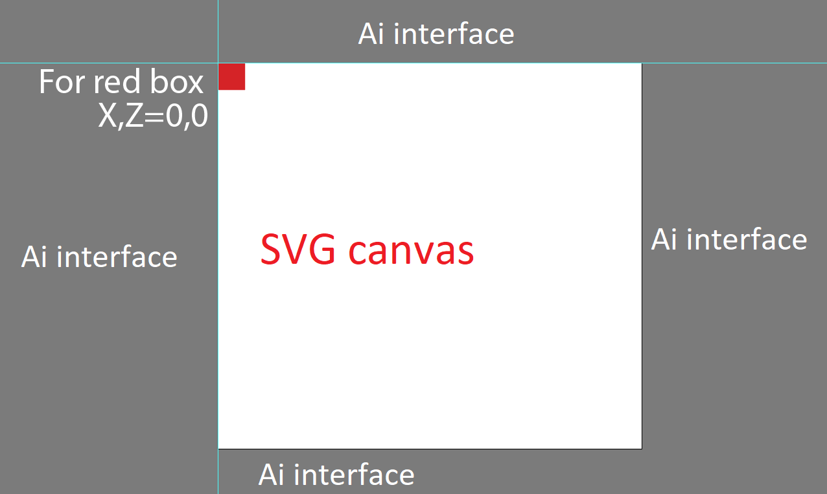

**Image 01**